

# **Final Project**

**Augustas Dumalakas**

**Tester Kaunas 3**

**2020 - 06 - 20**

**Work purpose**

**Register to www.darzo.lt website, try to buy a greenhouse, check compatibility with smartphone, find and log bugs in backlog.**

**Contents**

**Final Project** 1

**Work purpose** 2

**Site structure** 4

**Checklist and test cases** 5

Register Test Cases 6

**Shopping cart Test Cases** 7

**Shipping Test Cases** 8

**Founded bugs** 9

**Used tools** 10

**Improvements** 11

**Founded bugs and issues** 12

**Test design techniques** 13

**Refrection** 14

# **A screenshot of a cell phone Description automatically generatedSite structure**

# **Checklist and test cases**

(Full documentation is on backlog)

Examples of checklist:

|  |  |  |  |
| --- | --- | --- | --- |
| R 1.5 | Register form | 1 | Try to fill registration form with corect data |
|  |  | 2 | Try to fill registration form with incorect data |
|  |  |  |  |
| L 1.6 | Login form | 1 | Try to login form with registered account |
|  |  | 3 | Try to login form with unregistered account |
|  |  |  |  |
| S 1.7 | Shop cart | 1 | Add 1 item to shopping cart |
|  |  | 2 | Add 10 items to shoping cart |
|  |  | 3 | Add as many as can items to shopping cart |
|  |  | 4 | Remove items from shopping cart |
|  |  |  |  |
| P 1.8 | Personal info | 1 | Try fill all require fields in user info meniu |
|  |  | 2 | Try to change info in require fields in user info meniu |
|  |  |  |  |
| B 1.9 | Try buy | 1 | Add some goods to cart |
|  |  | 2 | Fill require info for shipping |
|  |  | 3 | Do a payment via bank |
|  |  | 4 | Do a payment with option pay with cash |
|  |  |  |  |
| CS 2.0 | Contact seller | 1 | Write email if you find cheaper stuff in other same eshops (for dicount) |
|  |  | 2 | Leave a feedback about a item you bought |
|  |  |  |  |
| G 2.1 | Google it | 1 | Try to find this website in google, bing or other search engine |
|  |  | 2 | Find information is it a secure and safe eshop |
|  |  |  |  |
| O 2.2 | Others |  | Try to run this web-site in other web-browsers |
|  |  |  | Try to run this web-site in mobile device |
|  |  |  | Try to run this web-page in tablet |

# Register Test Cases



# **Shopping cart Test Cases**





# **Shipping Test Cases**



# **Founded bugs**

(all info is in backlog)

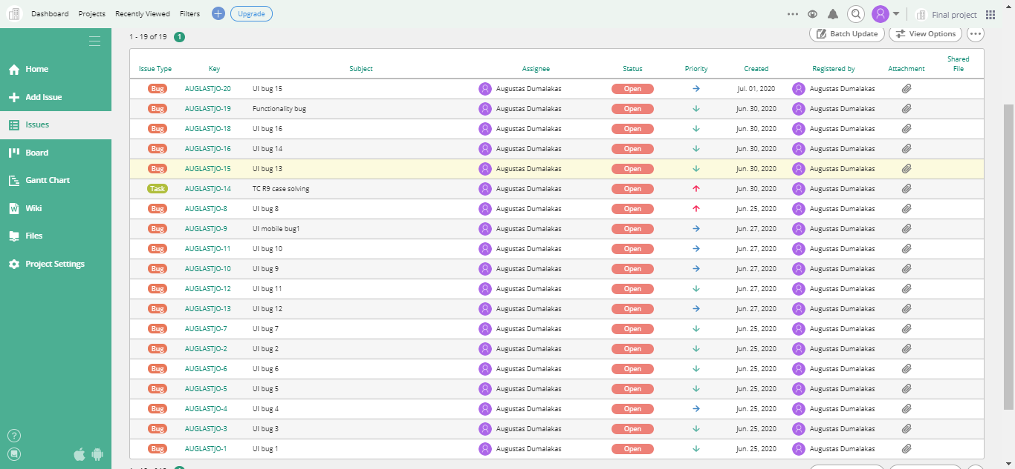

# **Used tools**

Notebook Dell alienware 13 r3, screen size 13“ resolution 1366x768,running google chrome, internet explorer, microsoft edge browsers with addons like adblocker, measure dimensions, developer tools.

Apple iphone 8 plus screen size is 1920x1080 (recommend use in landscape mode) with iOs 13.5.1 running safari browser

For documentation used “Microsoft office 365”.

For registering bugs used “[www.backlog.com](http://www.backlog.com)” and “snipping tool”.

For energy and motivation thanks to coffie and SDA 😊

# 

# **Improvements**

There is most is of UI bugs, spelling and translate mistakes in this website.

Site structure is spilled out, there is necessary submenu lists in which repeats main menu, same with some hyperlinks in bottom.

Not best compatibility with mobile device. Need to improve UI on portrait mode.

At now it is important to have social media links, but they are not working too.

Shipping is available only in Lithuania, so drop down list of country select can be removed.

You also can not select shipping type its only one delivery option.

To pay via credit card is not so simple and not so friendly user like pay via “Pay sera”.

# **Founded bugs and issues**

* Most is UI bugs
* Some functionality bugs
* Performance bugs only on not popular browser
* One security issue

Most of these is described in backlog website

Example:

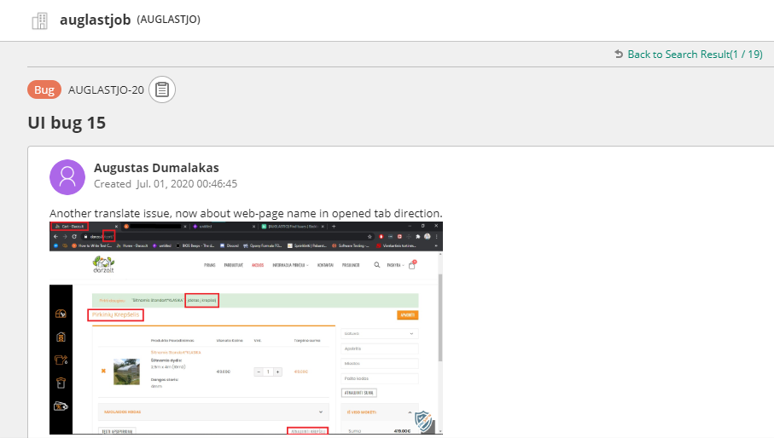

# **Test design techniques**

* AD-hoc testing
* Functional testing
* GUI testing
* Happy path testing
* Negative testing
* Performance testing

# **Refrection**

To test any page is always another challenge. Every page ,every button is similar but different in many ways.

Today i was trying to do first individual work and must say this was not easy.

Biggest difficult is time, then starting from open browser to do test cases you see the day goes out immediately.

I got some practice in this job and hope in future i get more and more jobs like this and be better tester.

In future I hope to test software and computers hardware in same time.